**Investigation into the Rise Time Dynamics of VECSEL Lasers**

Baksh. P D

School of Physics and Astronomy, University of Southampton, Southampton SO17 1BJ, United Kingdom

[pb4g08@soton.ac.uk](mailto:pb4g08@soton.ac.uk)

# Abstract

Table of Contents

Abstract 1

1. Introduction 1

2.Background Information 2

*Semiconductor Chip structure* 2

*Laser Noise and Green Noise* 3

*Laser Rise times* 3

3.Laser theory and Mathematical background 4

*Gain Medium* 4

*Photon Numbers* 4

*Bragg Mirrors* 4

*Dynamic Equations* 5

*Laser Modes and Mode beating theory* 6

4.Experimental Work 7

Methods 7

Features and Improvements to the experimental design 8

5.Transverse Electromagnetic Modes 11

6. The Rise Time Model 13

7. Results and Discussion 14

*Pump calibration and Input Output curves* **Error! Bookmark not defined.**

*Photon Rise Times* 14

*Photon Rise time as a function of output coupler* 15

*Photon rise time as a function of power* 15

*Cavity Lifetime* 16

*Gain saturation* **Error! Bookmark not defined.**

8. Conclusions and Future work 16

9. References 16

# 1. Introduction

This project aims to make transient measurements of an optically pumped semiconductor quantum well (OPS) vertical-external-cavity surface-emitting laser (VECSEL) at the onset of lasing [1]. The project looks to understand the rise time of a VECSEL laser, and extract certain parameters, specifically the cavity lifetime, from this understanding. The VECSEL laser encompasses the advantageous properties of a conventional semiconductor laser without compromising on the beam quality that is traditionally quite poor in other semiconductor lasers.

An optical chopper was inserted into cavity at a KHz frequency to modulate photon number in the cavity, and thus turn the laser on and off, whilst measurements of intensity were taken using a high speed photodiode. Pictures of the laser beam were taken using a camera with an infrared filter, to allow analysis of transverse modes.

The VECSEL work on the project has, for the majority, been completed in partnership with Edward Shaw. Where the laser required time consuming and careful alignment, work was divided equally. However, data was always obtained collectively.

# 2.Background Information

VECSEL development in the mid 1990’s has opened access to a wide range of wavelengths through band gap engineering [2]. The VECSEL structure provides a number of advantages: a low threshold, dynamic single-mode and relaxation free operation (by over damped oscillations), a long device lifetime, high power conversion efficiency and vertical emission from the substrate [3]. The optically pumped VECSEL converts a low quality diode beam, in to a near diffraction limited output beam of wavelengths potentially not accessible in current solid state lasers [4].

## *Semiconductor Chip structure*

Advances in semiconductor structures have allowed the growth of a semiconductor gain chip that can be engineered to fluoresce at a desired wavelength [2]. The active region of the chip is only a few half wavelengths thick, and hence performs the role of pump absorber, quantum well spacer, and optical spacer. The quantum wells are grown into this active region, positioned λ/2 apart, so as to align with the antinodes of the optical standing wave that will form in the chip [4].The distance between the quantum wells will determine the designed wavelength. At the air-semiconductor interface, a material layer of higher energy band gap material is used to stop carriers diffusing in a non radiative recombination. The last layer of the chip is a thin aluminium-free capping layer to prevent the structure from oxidation. Lower quality chips can be susceptible to “dark line defects”. These are a consequence of lattice miss match between the two or more alloys that form the semiconductor. As their lattice constants differ so there will be strains at the joining of the lattices. Heat produced from optical pumping can cause dislocation under compressive strain. This may induce a region of the chip that can no longer transport excited carriers to the quantum wells. This can be avoided by using strain balancing. This process adds an element to the structure, which induces tensile strain to compensate for the lattice miss match [1].

The active region is grown onto the multilayer Bragg mirror (27.5 periods) with a high reflectivity to ensure that the laser threshold is as low as possible. The mirror requires a good thermal conductivity to remove heat produced in the active region so that heat is successfully dissipated. The multilayer Bragg mirror is made of paired layers of semiconductor materials, each of a quarter wavelengths deep to give high reflectivity.

For the optically pumped VECSEL, design of these mirrors is far simpler. By only optimising optical performance and not electrical characteristics, the semiconductor can remain undoped and epitaxial growth is simplified [4].

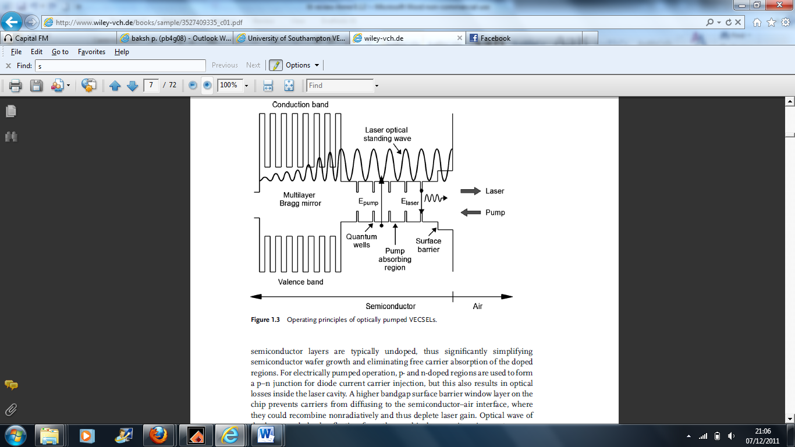

Figure[1.1]. Diagram shows the structure of the gain chip. The sinusoidal wave represents the E field Intensity.

The diode pump is constantly exciting carriers in the active region of the chip. Assuming the photon energy exceeds that of the material band gap; the carriers can diffuse into their respective energy bands and then get trapped in quantum wells, almost instantaneously. The peak gain wavelength, differential gain, gain bandwidth and quantum efficiency will all be dependent on the carrier concentration and temperature. A standing wave forms inside the chip from back reflection of the Bragg mirror, such that the quantum wells are positioned at the antinodes of the field [2]. Optically pumping the laser is extremely advantageous when obtaining high powers. The spot size can be easily controlled to ensure the entire active region is pumped [5]. Furthermore, optically pumping the gain chip simplifies the structure of the active region; the material can remain un-doped, because a pn junction is not required that would otherwise be needed using electrical pumping.

## *Laser Noise and Green Noise*

Green lasers have a variety of functions/purposes./uses. These include pumps and biomedical applications. They are produced by intracavity doubling of lasers operating in the IR spectrum range. Up until recently, Neodymium doped lasers were used with a frequency doubling crystal to produce green light. However they have a problem caused by fluctuations in fundamental photon numbers, and nonlinear loss in the doubling crystal that causes a problem of green noise.

Any monochromatic laser will exhibit two types of noise; intensity noise and phase noise. Intensity noise is defined as a fluctuation in the laser output power. The measurement of output power noise will depend on the speed of the detector being used. Phase noise is related to the optical phase of the output beam, which causes the finite line width of the main peak.

Current laser cavities can support a range of longitudinal cavity modes. Particularly in long cavities, the intra cavity beam intensity is divided between multiple longitudinal modes each with a different frequency. Division of this frequency gives the noise, and this division is dynamic and random. For normal operation (without frequency doubling), this form of intensity noise is very small. However, when using a frequency doubling crystal, in a cavity supporting many longitudinal modes, there is a significant quantity of noise, and this is known as the green noise problem [6]. The explanation for such noise, follows that the frequencies generated from second harmonic generation and sum frequency generation are possible (sum frequency is the addition of frequencies with two different longitudinal modes). The sum frequency generation is a dynamic effect, and the intensity of one mode, is dependent on the gain of another mode [7]. In summary, green noise is a result of the summation and competition of longitudinal modes [8].

Methods have been put in place to combat the problem of green noise. The first method used longer laser cavities so that the intra cavity power would be split over a larger number of modes. Consequently, the noise is reduced by averaging the effect of a greater number of modes. This solution is adequate in some instances, however not for noise sensitive applications. A more obvious solution is to reduce the number of longitudinal modes, so that the laser operates on a single mode. Therefore, there can be no dynamic fluctuations in the cavity [6].

VESCEL lasers produce very small quantities of green noise. This is because the lifetime of the upper state in a VECSEL is approximately of the order of nanoseconds and so no gain is stored. Consequently, there are no dynamic mode fluctuations and thus there is little mode interference. However, in other lasers, e.g. Nd:YAG, relaxation oscillation noise will be driven by pump laser intensity fluctuations [9].

## *Laser Rise times*

Initially pumping yields a large gain due to the large amplitude produced. The energy in the laser cavity then oscillates between photon number, and the gain until the laser reaches steady state [10]. This is caused by an upper state lifetime exceeding the cavity dampening time. As a result, there is a change in power leading to relaxation oscillations. This type of laser will follow class B dynamics e.g. Nd-YAG. A VECSEL laser follows class A dynamics, that is, within the order of microseconds, the carrier population in the semiconductor and the photon number in the cavity, will have reached their steady state values [11].

An example of an application of a VECSEL based on its class A dynamics, is Intracavity Laser Absorption Spectroscopy (ICLAS). VECSEL lasers can be used with ICLAS to produce highly accurate measurements in spectroscopy. Gas is placed within the laser cavity of a laser operating over a high number of longitudinal modes, and thus giving a broad band width. With each photon round trip, absorption of specific wavelengths occurs, and the sensitivity is a direct result of the number of round trips. The spectrum must be taken at a specific time, in order to see enough absorption before it becomes saturated [12].

# 3.Laser theory and Mathematical background

## *Gain Medium*

The gain is defined as the ratio of the output intensity from the gain medium to the input intensity. It can be represented as an exponential of the gain coefficient, g [13].

$G=\frac{I_{out}}{I_{in}}=\exp{(g)}$ (1)

The gain in a solid state laser such as Nd-YAG is a linear relationship as a function of pump power, whereas the gain for a semiconductor laser is given by equation (2)[2].

$g\left(N\right)=g_{0}ln⁡\frac{N}{N_{0}}$ (2)

$G\left(N\right)$*= Semiconductor modal gain*

$G_{0}$*=Semiconductor material gain parameter*

$N$*= carrier Number*

$N_{0}$*=Transparancy carrier density*

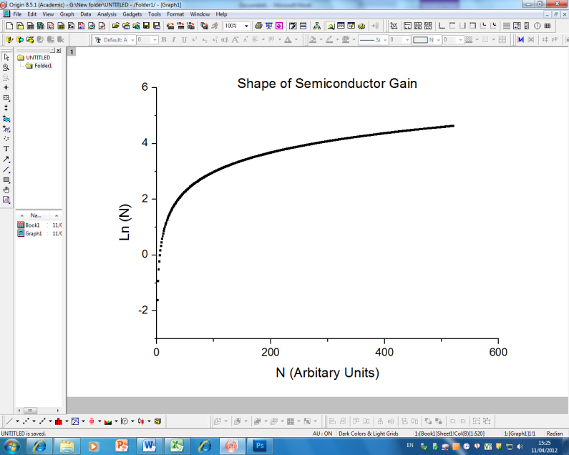

It can be seen that at the point at which the gain is zero, $N_{0}=N$, and this point is referred to as the transparency carrier density. The gain in the semiconductor differs from an atomic transition in the solid state laser, such that is it is provided from an interband transition between the electrons of the conduction band and the holes in the valence band. Further complicating the semiconductor gain is the fact that the electrons and holes are not stationary, unlike the atomic energy states [2].

## *Photon Numbers*

To calculate the number of photons in the laser cavity, $∅$, the round trip time, $τ$, must first be calculated. The round trip time is given by $τ=\frac{2l}{c}$, where $l$ is the total length of the cavity and c the speed of light in a vacuum [14]. It is assumed during the work for this report that $c_{air}=c$.

A measurement of the power of the laser beam can yield the intracavity power that is dependent on the percentage transmission value of the output coupler, $ϵ$, expressed as a percentage. Trivially the intracavity power is equal to $P_{ic}=\frac{P}{ϵ}$. The energy si calculated from the product of the roundtrip time and intracavity. Assuming the peak frequency of the output laser beam is a known value, then the cavity photon number is calculated.

$∅=\frac{P_{Ic} τc}{ħλ}$ (3)

Photons are designed to leave the cavity to enable lasing in the output beam; however other effects will decrease the photon lifetime of the cavity (the time a photon exists in the cavity). Losses are caused by absorption in cavity materials, and scattering off imperfect mirrors (scratches and dirt) along with misalignment of the cavity. Physically, since the nature of the beam is Gaussian, photons are lost by diffraction of finite sized mirrors and the output coupler.

## *Bragg Mirrors*

The Bragg mirror configuration is the most efficient mechanism for near perfect reflection. Pairs of $λ/4$ layers of two different refractive index materials form the structure with an exponential decrease in transmission with distance that can be calculated using the matrix [15].

$R={\left[\frac{1-\frac{n_{T}}{n_{0}}{(\frac{n_{2}}{n_{1}})}^{2N}}{1+\frac{n_{T}}{n_{0}}{(\frac{n_{2}}{n_{1}})}^{2N}}\right]}^{2}$ (4)

$N$*=Number of layers*

$n_{0}$*= refractive index for input material*

$n_{T}$*=refractive index for transmitted material*

$n_{1}$*= refractive index for first material layer*

$n_{2}$*=refractive index for second material layer*

The reflectivity of the layers causes a “stop band” that characterises the region of high reflectivity as a function of wavelengths, and thus the thickness of the layers must be carefully considered along with the laser operational wavelength [15].

## *Dynamic Equations*

To understand the equations describing the dynamic variation of photon number and the population inversion, three transitions mechanisms are considered. The spontaneous emission rate, $A_{21}$, the stimulated emission rate, $B_{21}ρ(ω)$, and the absorption rate, $B_{12}ρ(ω)$, where $ρ(ω)$ is the energy density. The rate of change of the atomic population between levels is given by;

$\frac{dN_{2}}{dt}=-N_{2}B_{21}ρ\left(ω\right)+N_{1}B_{12}ρ\left(ω\right)-N_{2}A_{12}$ (5)

Equation (5) shows that both the spontaneous emission and stimulated emission decrease upper level population, $N_{2}$,whilst absorption increases population. At equilibrium the Boltzmann distribution applies;

$\frac{N_{2}}{N_{1}}=e^{\frac{-ђω}{kT}}$ (6)

The Boltzmann distribution implies that for all T $>0$ the population cannot achieve $N_{2}>N_{1}$ whilst being in thermal equilibrium and thus pumping is required to create a population inversion [16].

The dynamic variation of amplitude after lasing onset can be described for the solid state laser based on the four level laser model. In the four level laser model, the pump can excite atoms from the ground level laser state by a strong optical field to a level denoted by $N_{3}$. The lifetime of this energy level is extremely small, and the excited atom quickly drops down an energy transition to $N_{2}$ by a non radiative transition (all energy deposited as heat). The laser gain transition occurs from $N_{2}$ to $N_{1}$, where the atom in $N_{1}$ quickly returns to ground by another non-radioactive transition. Thus a population inversion can always be obtained.

The equations for both cavity photon number and higher level population number for the 4 level laser operating a class B regime are given by;

$dN_{2}=\left(Γ-\frac{\frac{c}{n}σ}{V}∅N_{2}- \frac{N_{2}}{τ}\right)dt$ (7)

$d∅=\left(∅\left[V_{a}\frac{\frac{c}{n}σ}{V}N_{2}- \frac{1}{τ_{c}}\right]\right)dt$ (8)

$N_{2}$*= Population number in the higher energy state*

$∅$*= Cavity photon number*

$V$*= beam volume of cavity*

$τ$*= Upper state cavity lifetime*

$V_{a}$*=Volume of active region*

$Γ$*= pumping rate*

$τ_{c}$*=Cavity lifetime*

From these equations and applying a small perturbation, equations for the frequency of relaxation oscillations are obtained [BILL NOTES]

$ω=\sqrt{\frac{x-1}{ττ_{c}}}$ (9)

*x= Pump parameter- ratio of pump power to threshold pump power*

Equation 8 makes an assumption that the relaxation frequency $ω^{2}≫{\frac{1}{τ_{c}}}^{2}.$ It can be seen that for typical VECSEL values that show a very low upper state life, the relaxation frequency will be very high and steady state operation will be achieved almost instantly. For ${τ_{c}}^{-1}={10}^{6}s^{-1}$ and $τ={10}^{9}s^{-1}$ $ω$ will be approximately 10MHz. Thus relaxation oscillations of this frequency will not be seen in a VECSEL laser. However in solid state lasers such as Nd-YAG they will be seen. [11]

In the class A regime the dynamical equations are given by (ignoring the constants given in equation 7 and 8):

$\frac{dN}{dt}= Γ-\frac{N}{τ}-G(N)∅$ (10)

$\frac{d∅}{dt}=G\left(N\right)∅-\frac{∅}{τ}$ (11)

Making the assumption that all photons are operating at the same longitudinal mode, and G(N) is the modal gain. Dividing through by the photon number it follows.

$\frac{1}{∅}\frac{d∅}{dt}= G\left(N\right)-\frac{1}{τ}=\frac{dln∅}{dt}$ (12)

A graph of $\frac{1}{∅}\frac{d∅}{dt}$ against time will enable a value of G(N) to be obtained.

At laser threshold equation (13) must hold for the VECSEL laser that describes the condition where gain is equal to cavity loss.

$R_{1}R_{2}T_{loss}\exp\left[2∁g_{th}N_{w}L_{w}\right]$ = 1 (13)

$R_{1}$*= Mirror reflectivity of mirror 1*

$R_{2}$*= Mirror Reflectivity of mirror 2*

$T_{loss}$*= Transmission factor due to cavity losses*

$∁$*= Longitudial confinement factor- specific to the gain structure to characterise the overlap of the quantum well spacing and the standing wave .*

$g_{th}$*=gain at threshold*

$N_{w}$*=Number of quntum wells*

$L_{w}$*=length of the quantum wells*

For the gain, carrier lifetime can be calculated as a combination of 3 coefficients; monomolecular A, biomolecular B, and Auger recombination C.

$\frac{1}{τ(N)}=A+BN+CN^{2}$ (14)

The carrier density can be calculated from the properties of the chip, and the incident pumping power

$N=\frac{η_{abs}P_{p}}{hν_{p}\left(N_{w}L_{w}A_{p}\right)}τ(N)$ (15)

By substituting equation (2) with equation (12), the carrier density at threshold, $N_{th}$ can be calculated.

$N_{th}={N_{0}(R_{1}R_{2}T_{loss})}^{-(2∁g_{0}N_{w}L_{w})}$ (16)

Substituting $N_{th}$ into equation (14) gives threshold power.

$P_{th}=N_{th}\frac{hν(\left(N_{w}L_{w}A_{p}\right)}{η_{abs}τ(N_{th})}$ (17)

The output VECSEL power is

$P_{las}=(P_{p}-P_{th}) η_{diff}$ (18)

$η_{diff}$*= laser differential efficiency*

Where $η_{diff}$ is defined as

$η_{diff}=η_{out}η_{quant}η_{rad}η_{abs}$ (19)

The output efficiency, $η_{out}$, is given as

$η_{out}$ = $\frac{\ln{(R_{2)}}}{ln⁡(R_{1}R_{2}T_{loss)}}$ (20)

$R_{2}$ is the reflectivity of the output coupler. The quantum efficiency is given by

$η_{quant}=\frac{λ_{pump}}{λ_{laser}}$ (21)

This is the ratio of pump wavelength to the laser wavelength. The $η_{rad}$ is given by a combination carrier density at threshold and the monomolecular recombination, biomoleuclar recombination and Auger recombination coefficients [2].

$η_{rad}=\frac{BN_{th}}{A+BN_{th}+CN_{th}^{2}}$ (22)

## *Laser Modes and Mode Beating Theory*

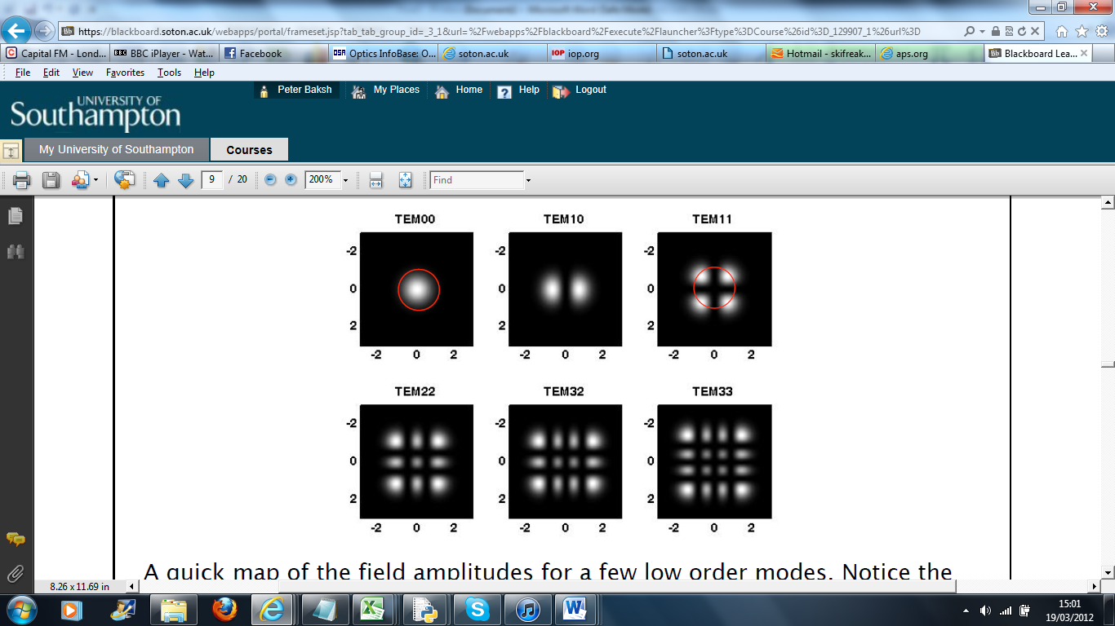Both longitudinal and transverse modes are used to describe a laser. For this project transverse modes are more interesting, since the longitudinal modes are just showing the range of frequencies the cavity is supporting. The Transverse Electromagnetic Modes (TEM) describes the Gaussian beams in the cavity, and will determine the shape of the output laser beam. Usually, only the fundamental mode ${TEM}_{00}$ is required for most laser purposes. However, when power surpasses the requirement of beam quality higher order modes will be accepted. In the VECSEL laser, higher order modes will be seen with spot miss matching on the gain chip, between the pumping laser, and the cavity beam.

Figure 3.1. –Transverse Electromagnetic Modes

[need to reference Bill B)

Laser operation will yield different frequencies in the cavity dependant on the transverse mode that the laser is operating in. The frequency can be calculated by:

$υ_{nlm}=\frac{c}{2L}[n+\frac{1+l+m}{π}\cos^{-1}\left(±\sqrt{g_{1}g_{2}}\right)]$ (23)

$υ_{nlm}$*=Frequency of the mode as a function of n,l,m*

$L$*= Cavity length*

$n$*= Number of longitudinal modes*

*m,l= Transverse mode index*

$g_{1}$*=Cavity parameter at mirror 1*

$g_{2}$*= Cavity parameter at output coupler*

If the laser operates in multiple modes at the same time, then these frequencies will interact, and follow spatial mode beating theory.

The condition for resonance is;

$υ_{l_{1}m}\left(z_{1}\right)-υ_{l_{2}m}\left(z_{2}\right)=qπ$ (24)

$z_{1}$*=Rayleigh range of mirror 1*

$z_{2}$*= Rayleigh range of mirror 2*

$q$*=Integer*

At the beam waist, $w_{0}$, z is equal to 0.

$υ_{l_{1}m}\left(z\right)=kz-\left(l+m+1\right)\tan^{-1}\frac{z}{z_{0}}=qπ$ (25)

$z_{0}=\frac{πw_{0}^{2}n}{λ}, n≈1 for air filled cavity$ (26)

The frequency splitting between two special modes (${q,l}_{1,}m_{1}$) and (${q,l}_{1,}m_{1}$).

$k_{1}d-\left(l_{1}+m_{1}+1\right)\left(\tan^{-1}\frac{z_{2}}{z_{0}}-\tan^{-1}\frac{z_{1}}{z_{0}}\right)=qπ$ (27)

$k_{2}d-\left(l_{2}+m_{2}+1\right)\left(\tan^{-1}\frac{z_{2}}{z_{0}}-\tan^{-1}\frac{z_{1}}{z_{0}}\right)=qπ$ (28)

*d= $z_{1}$- $z_{2}$*

The beat frequency can then be given by:

$∆υ_{}=\frac{c}{2πd}\left[\left(l_{1}+m_{1}\right)-\left(l_{2}+m_{2}\right)\right]\{\tan^{-1}\frac{z_{2}}{z_{0}}-\tan^{-1}\frac{z_{1}}{z_{0}}\}$ (29)

Simplifying the equation for the confocal cavity where $d=R_{1}=R_{2}$;

$∆υ_{}=\frac{1}{2}∆(l+m)\frac{c}{2d}$ (30)

In the case of the plane/ plane cavity ;

$∆υ_{}=∆(l+m)\frac{c}{2πz_{0}}$ (31)

# 4. Experimental Work

*Description of gain structure*

The gain chip, ES 1908, was grown by molecular beam epitaxy at ETH Zurich. It contains 27.5 pairs of $AlAs$ and $GaAs$ at a thickness of ¼ wavelength and was designed to emit photons at 1 micron. It actually emits at 1015nm (it is common to get a 1% random growth error). The active region is 7/2 wavelengths thick with 6 ${In}_{0.2}G_{0.8}A_{}$ quantum wells 8nm thick. The chip is finished with a ¼ wavelength $AlAs$ window layer and a 8nm $GaAs$ capping layer.

## *Methods*

All experiments made on the laser involved a cavity with good alignment, to reduce photon loss, to ensure a low threshold for lassing and a high maximum output power. Initially, the pump was roughly aligned onto the chip and a high magnification camera was used to look at the chip. From this, dark line defects could be identified, and the pump laser could be aligned such that it looked to be focusing between dark line defects. Following this, the spherical mirror was aligned using a CCD camera with an infrared lens to see the beam. Alignment could be adjusted through chip and mirror, height along with angle. The CCD camera was placed opposite the spherical mirror so that it viewed the mirror in a tight fold. Adjustment of the spherical mirror was made so that it caused an intense bright region on the CCD. The output coupler was then placed between the mirror and camera, and adjusted until enhancement was found. The output coupler was then fixed down, and fine adjustments of all components were made until lassing was obtained. Once lassing was found, a clear glass slide was used to divide the output beam and direct some of the beam towards a divergent lens, and onto a white screen. The CCD was placed such that it displayed the laser beam on the screen. By viewing the beam and adjusting the cavity, threshold could be lowered.

Rise time measurements on the cavity were made using an optical chopper in the cavity. The chopper was placed as close to the output coupler as possibly to allow the chopper to cut the beam near the beam waist. The optical chopper was connected to the oscilloscope via a current voltage pre-amplifier. At the output beam beyond the glass slide, the photodiode was positioned which connected to a pre-amplifier that in term connected up to the oscilloscope. Data of rise times was obtained from oscilloscope readings.

Output power was measured using a *Melles Griot Broadband Power/Energy meter 13PEM001*. The power meter was positioned directly behind the output coupler such that beam divergence was limited, and readings were taking straight from the power meter. Similarly, reflection of the chip was measured using the same power meter.

Beam profiles were obtained by two methods. Initially in the project, a fine blade was scanned across the beam on a translation stage and power readings taken. From the differential of the curve a beam profile was obtained. Later on in the project beam profiles were obtained from the bitmap images produced from the CCD camera. A code written in Python was used on the bitmap file to obtain a grid of intensities on the grey scale images, such that each cell gave an intensity reading between 0 and 256 of the pixel. A plot of the summation across the direction of a given axis gave the desired beam profile.

*Cavity Design*

The first cavity to be produced was a simple liner cavity. The purpose of the cavity was to become familiar with the VECSEL laser, and the techniques required to obtain stimulated emission..

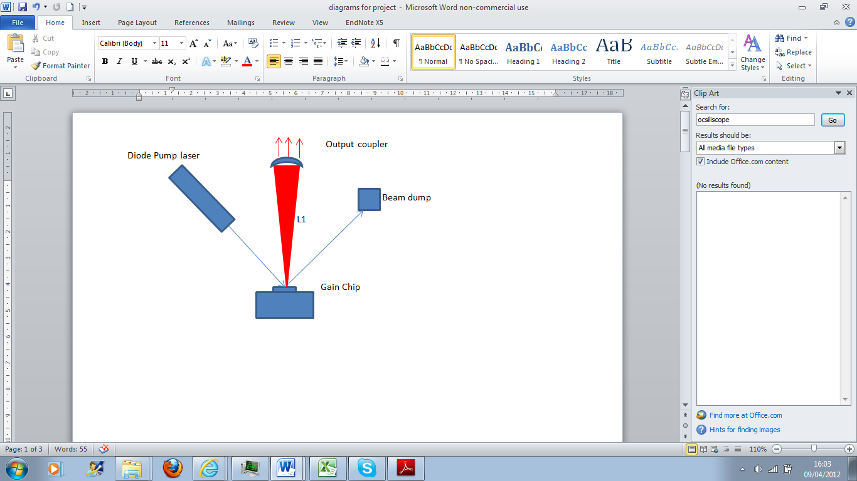

Figure 4.1. cavity design- hemispherical cavity

The cavity then progressed to an L shaped cavity with a tight fold. Alignment of this cavity was more challenging. The purpose of the set up was to potentially allow further components into the cavity, such as an optical chopper and, or, a nonlinear crystal. Cavity arm distances could be theoretically calculated using ray matrixes or using existing programs such as *Luckspot.* This gives the theoretical distance, however manual adjustment would be required from these distances.

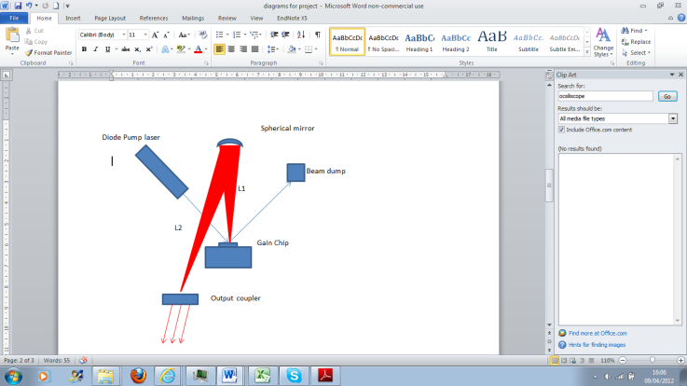

Figure 4.2. cavity design with 2 arm sections. Using R= $∞$ at the output coupler the cavity is comprised of two hemispherical cavities

## 

## *Experimental Artefacts and Improvements to the Experimental Design*

Throughout the experimental work, changes to the method were made in order to reduce equipment defects, improve results, and to obtain more physics from the experiment.

1. Initially the set up used did not use a current/ voltage pre amplifier. This caused impedance problems in the set up that produced data graphed as figure 4.3. This is not showing the rise time, more a reflection at an interphase. Introduction of the current pre amplifier eliminated this problem. The current pre amplifier used was *Standford research systems Model SR570* on a high bandwidth setting

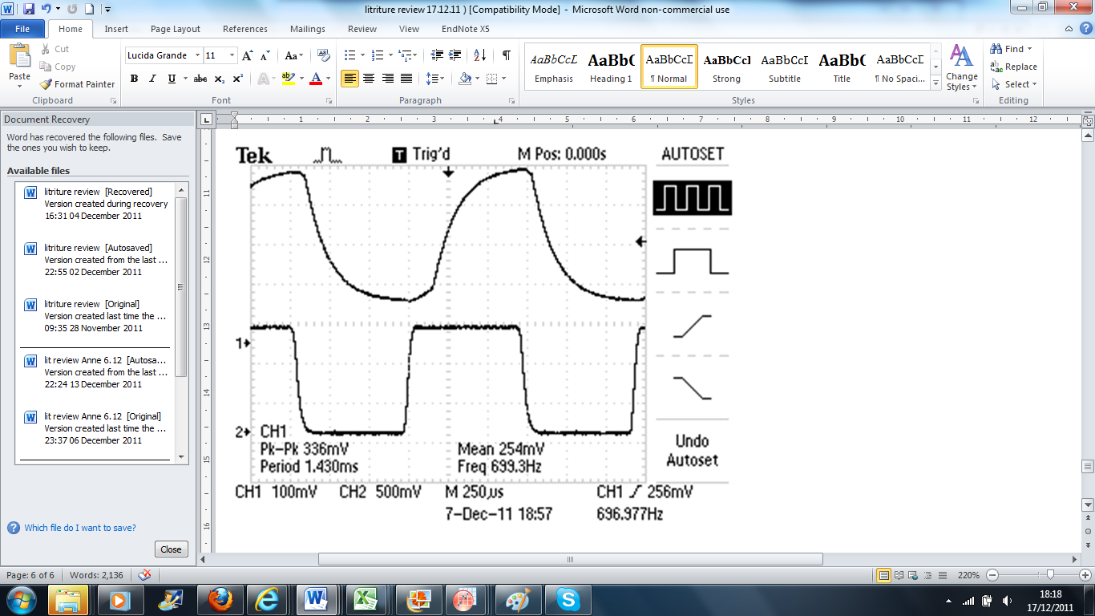

Figure 4.3. Graph taken using two arm cavity with an optical chopper and photodiode. Impedance defects are seen

2. The glass slide used in the set up was to split the beam to allow a spot image, and allow rise time data to be obtained at the same time from the photodiode. After analysis of the CCD images it was suspected that some noise could have been caused by wave interference between light reflecting of the front and the back of the slide. To compensate for this, a glass wedge was used splitting the direction of the beam of the front interface and that of the back so no interference occurred.

3.Intracavity doubling was attempted in the cavity . The cavity was being designed such that it could output green light using a frequency doubling crystal, placed after the output coupler in Figure 3.2. The crystal was $LiIO_{3}$ with a 2mm thickness cut for type 1 phase matched at SHG 1015-1050nm. It was placed outside the cavity such that it would not affect the dynamics inside the cavity, by altering optical lengths. After time no green light was found. By simple calculation, using the 0.3% output coupler intracavity power is found to be 300 times as large inside the cavity and so it was proposed to place the crystal inside the cavity. This was to increase the power to overcome the losses in the crystal. However after alignment no green light was found. Supplementary work was performed by Keith Wilcox. The absorption loss at 1027nm, using a Nd:YLF CW laser with an output of 1 W, was measured by focusing the beam down to a similar laser mode size to that used in this project . The power was measured before and after the crystal and loses were found to be $\sim 10\%$; much higher than expected. The crystals are hydroscopic, thus react with water, which degrade over time, and it is likely that this led to the crystal having a high loss. [reference keith]

4. Class B dynamics/Mode Beating/ Photodiode saturation problem. The last feature to the experimental design was to account for the following discussion.

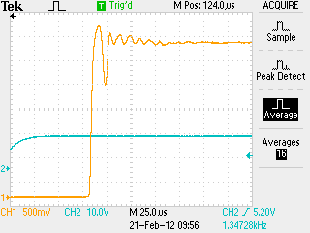

Figure 4.4- Osciliscope print of V cavity. Oscilations recorded.

Data collected from 21.2.12

cavity was orgininally theshold at 0.55A however after tinkering to get class B threshold is 0.71A

Print was taken at 1.28 A

The trace shows what looks to be similar pattern to that of relaxation oscillations, class B dynamics, found in a laser such as Nd-YAG where at laser turn on, the energy oscillates between cavity photons and gain

Referring to section 3, equation 9 was derived from applying a perturbation to the steady state solutions and assuming $ω^{2}≫{\frac{1}{τ_{}}}^{2}$. This assumption is required in the previous step to deriving the relaxation frequency. The perturbed system leads to an equation similar to that of the harmonic oscillator with the solution.

$δϑ=δϑ_{0}exp⁡(pt)$ (32)

$p=-\frac{1}{τ_{}}±\sqrt{\frac{1}{{τ_{}}^{2}}-ω^{2}}$ (33)

It is known for a VECSEL laser of this kind the carrier lifetime is $τ_{carrier}={10}^{9}s^{-1}$. From taking the frequency of oscillations from the figure it is clear the product inside the square root will be positive. This gives a solution for photon number of a real exponential as opposed to an imaginary product would give an oscillating solution. It can be concluded then that the oscillations seen are not due to class B dynamics.

*Spatial Mode beating theory*

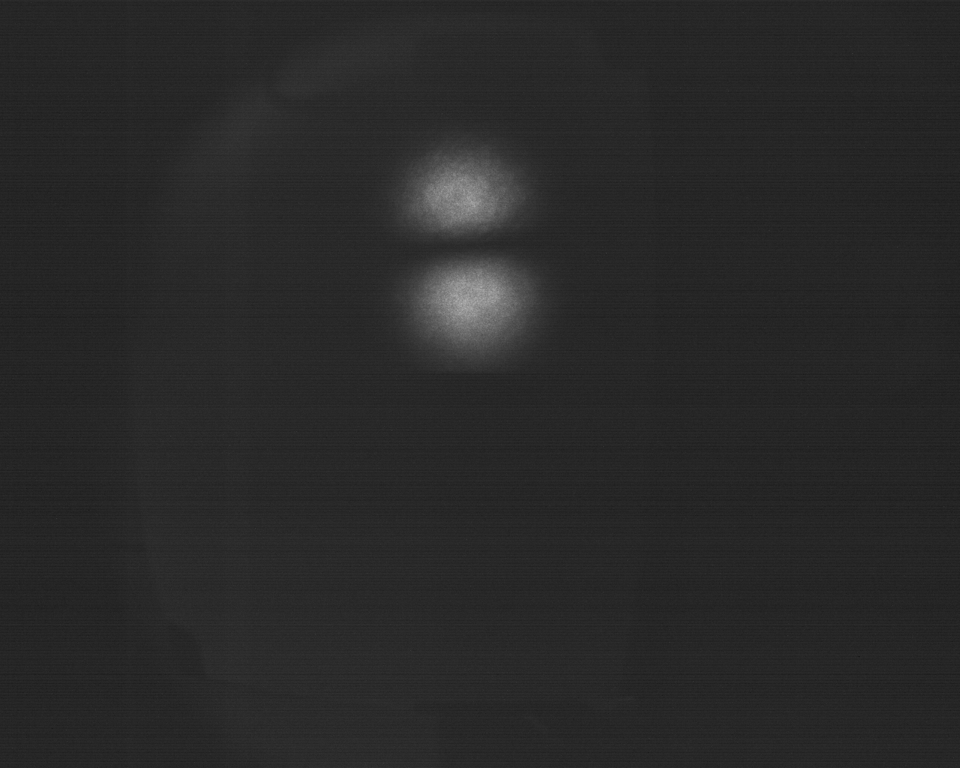

Figure 4.5. Image ${TEM}_{10}$- Note the image is taken at 90 degrees

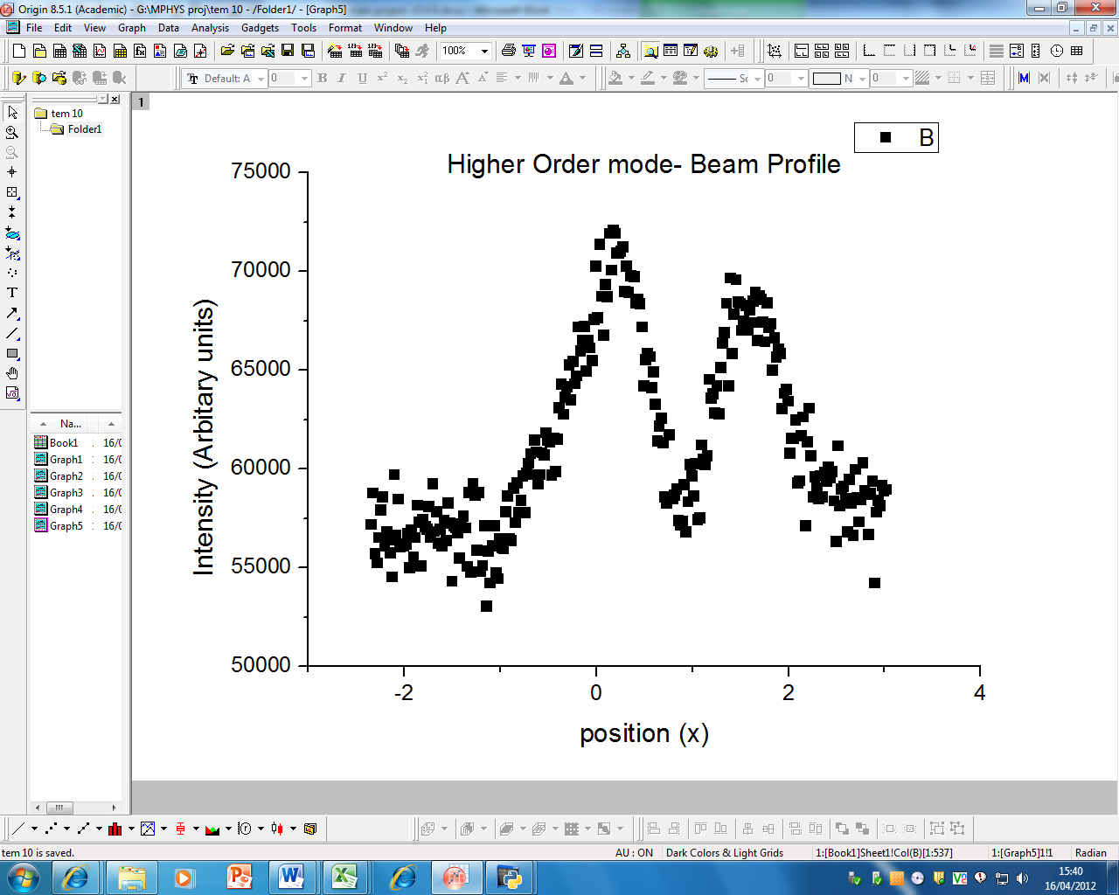

Figure 4.6. Image ${TEM}_{10}$ beam profile taken from \CCD image shown in figure 3.5

It is seen from figure (4.5) and figure (4.6) that the laser is operating outside the fundamental mode, most likely to be in TEM 10. The hypothesis at this point was made that the laser modes in the cavity could be mode beating. To examine this theory the derivation from section 3 is used. Initially for the purpose of composing a ray matrix of the elements the cavity is treated as two flat mirrors and a thin lens

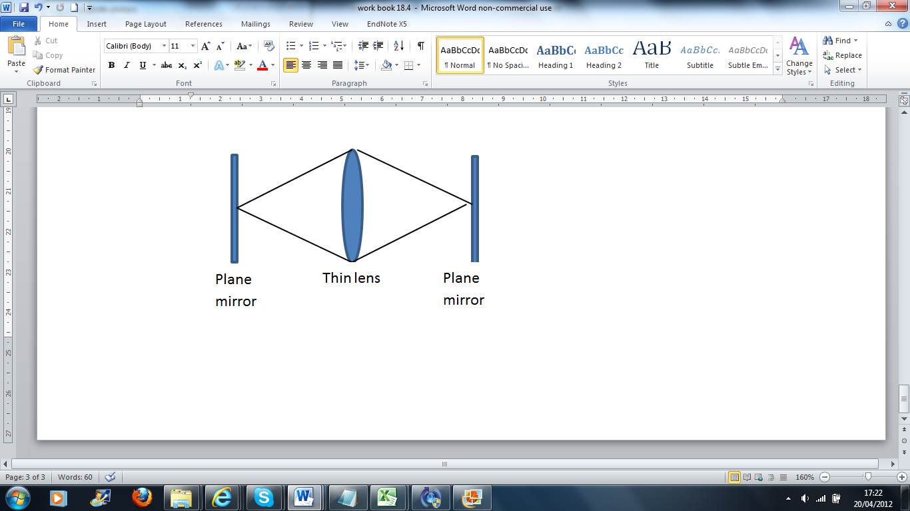

Figure 4.7

The ABCD matrixes for cavity stability can then be calculated [ bill broklesby notes]. For the cavity the matrix was

$$\begin{matrix}0.98 & 0.2 \\ -0.1 & 0.99\end{matrix}$$

For the plane plane mirror cavity both A and D are given as 1 so to make an order of magnitude approximation as to whether the artefact could be mode beating a plane plane cavity is used as an approximation .

To find the Rayleigh range to inset into equation (34)

$Z_{0}=\left[\frac{1+g}{4(1-g)}\right]l^{2}$ (34)

*g=laser g paramters- we assume 0.99 in this case*

*l= cavity length*

This gives an approximate solution for $Z_{0}$ = 2.19m

Inserting this into equation [] the frequency for mode beating is $2.4×{10}^{7}$ Hz. The frequency of oscillation of the artefact is $1×{10}^{5}$. This implies the equation to be 2 orders of magnitude different and so the data is unlikely to be exhibiting mode beating.

It was proposed that the photodiode was getting saturated by the laser and this was causing the oscillations. The method was adapted such that neutral density filter was placed in front of the photodiode. This eliminated the oscillations that were being seen, and the rise time then showed to follow a typical class A regime.

Thus the final set up for the experiment is given (figure 3.8)

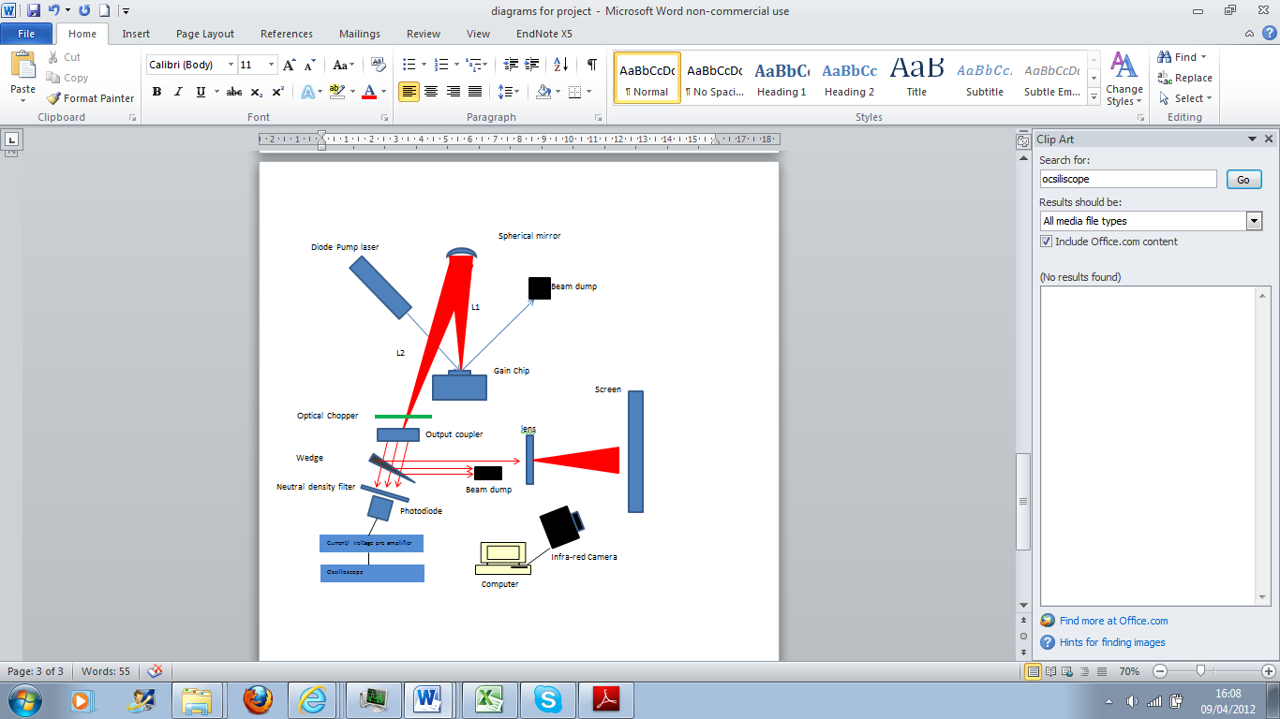

Figure 4.8- Final experimental set up

*Final Cavity*

L1= 76mm and L2=146mm

# 5.Transverse Electromagnetic Modes

Throughout the project, several moderations were made to the cavity to achieve a specific goal e.g Low threshold power, high maximum power. For most purposes it is desirable to have the laser operating in the fundamental mode ${TEM}_{00}$, however a miss aligned laser, that has poor mode matching on the gain chip will access higher order modes. Usually this is avoidable, however sometimes to obtain higher powers, and to pump a larger region of the gain chip higher order modes will be accessed. Some examples of laser modes discovered during experimentation are shown.

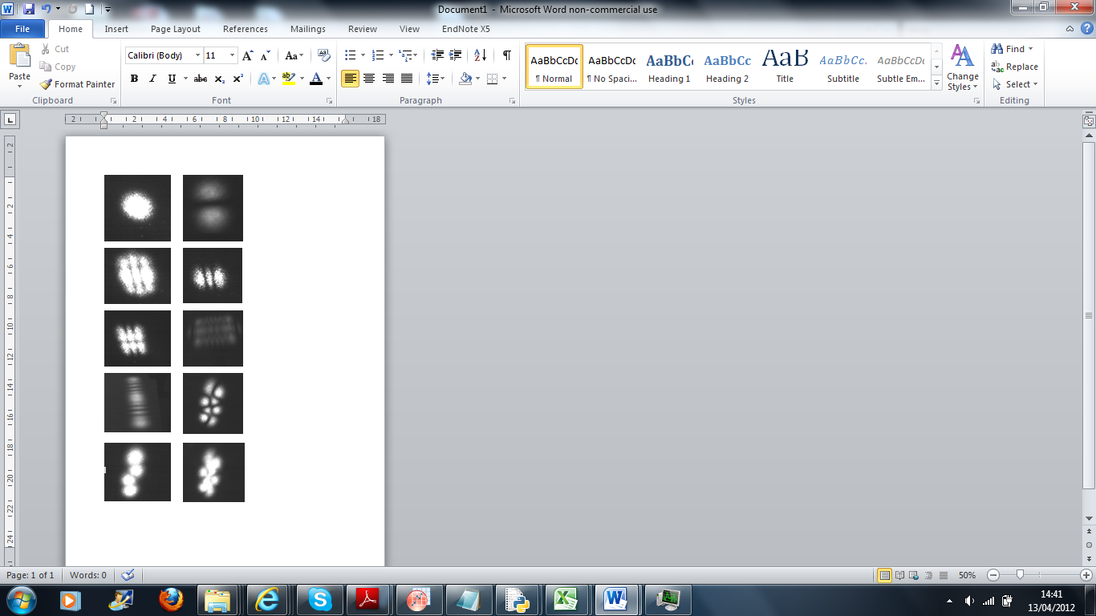

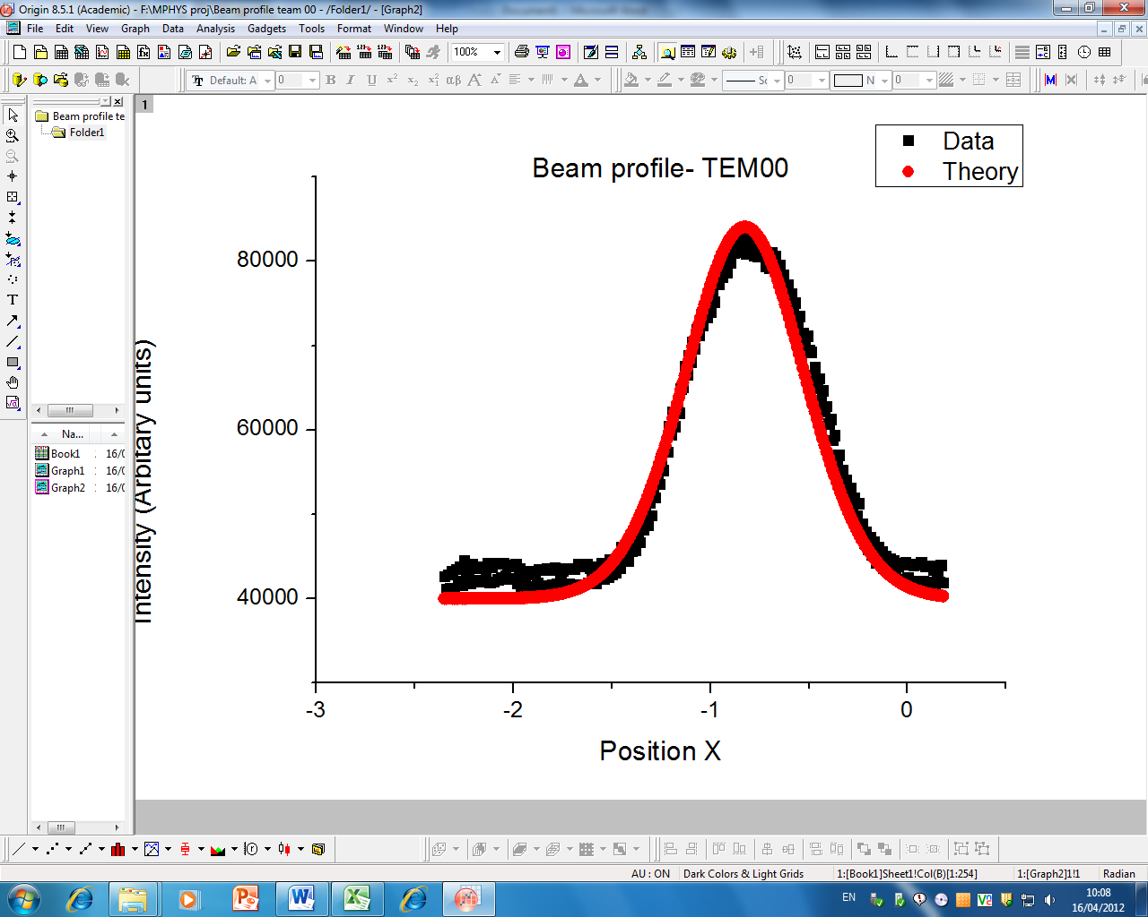

Figure 5.1- diagram of cavity modes found throughout the project

Typically it was found that the elaborate mode patterns shown gave a very high threshold power and poor output power (thus not much time was devoted to investigation of these modes), both as a result of poor alignment of the cavity. The lower order TEM modes can be plotted against the Gaussian functions in order to analyse the quality of the laser beam.

The fundamental mode can be modelled by the Gaussian function for the amplitude of the electric field propagating in the z direction

Figure 5.3- Graph showing the beam profile for ${TEM}_{10}$

$A\left(x,y,z\right)=\frac{A_{0}ω_{0}}{ω}exp⁡-\left[\frac{x^{2}+y^{2}}{ω^{2}}\right]exp⁡-\left[\frac{{(x}^{2}+y^{2})ik}{2R}\right]exp⁡-\left[iarctan\left[\frac{z}{z_{\begin{aligned}0 \\ \end{aligned}}}\right]\right]$ (35)

$A_{0}$*=Initial amplitude*

*k= wave vector*

The last term represents the Guoy Phase. The beam profile represents beam intensity and is simply the amplitude squared. The first term is the only term that describes the amplitude of the beam, and this curve is compared to data for the TEM00 mode.

Figure 5.2- Graph showing the transverse Gaussian mode

It is shown (figure 5.2) that the beam profile for TEM00 is very close to being perfect a Gaussian beam.

The amplitude for the TEM01 curve is given by

$A\left(x,y,z\right)=\frac{A_{0}ω_{0}}{ω}x.exp⁡-\left[\frac{x^{2}+y^{2}}{ω^{2}}\right]exp⁡-\left[\frac{{(x}^{2}+y^{2})ik}{2R}\right]exp⁡-\left[iarctan\left[\frac{z}{z_{\begin{aligned}0 \\ \end{aligned}}}\right]\right]$ (36)

[17]

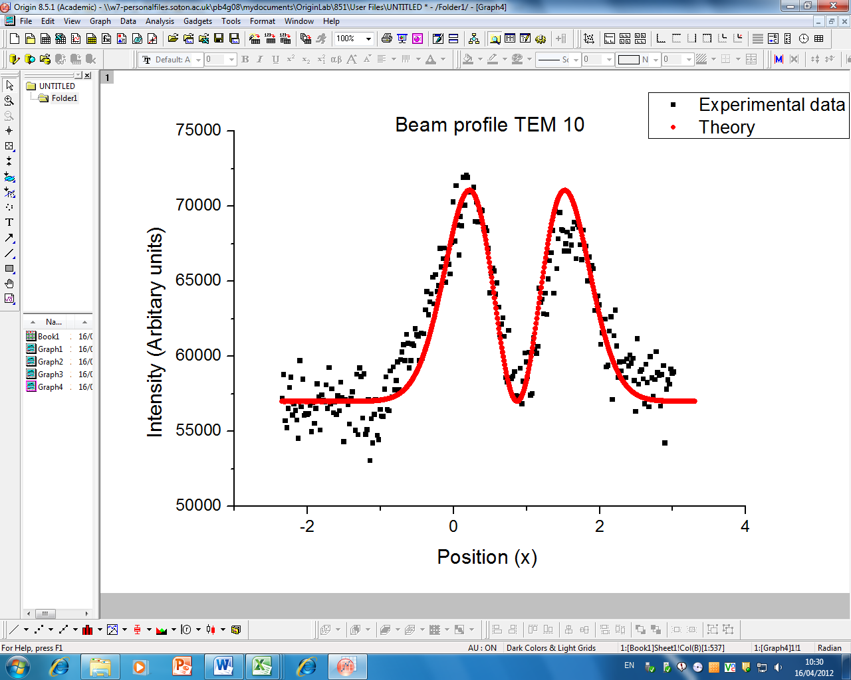

Figure 5.3- Graph showing the transverse Gaussian mode ${TEM}_{10}$

**6. The Rise Time Model**

The laser rise time model is based on the four level laser model, so an assumption to ignore semiconductor gain has been made. This is likely to cause a deviation to the data in the upper half of the rise time where logarithmic gain deviates from linear gain. In the model, carrier rate, photon rate and pump ratio are the input variables. From these carrier densities, gain parameter, pump rate and carrier density at threshold can be calculated. Pump threshold and Phi steady state are known experimental values, and so the fitting input parameters are photon rate and carrier lifetime. Through small time intervals a series of interactions are used to calculate the photon number, and thus a model of the rise of the photon number.

Starting from the 4 level rate equations, the photon number and carrier numbers are normalised. Then the assumption that carrier lifetime is much much less than the cavity lifetime it can be said the normalised carrier number follows the normalised photon number adibiaticly. This simplifies the rate equations. Mathematical derivation shown in appendix 1.

Graphs below show how simplification of the rate equations is valid assuming the carrier number follows the photon number adibiaticlly.

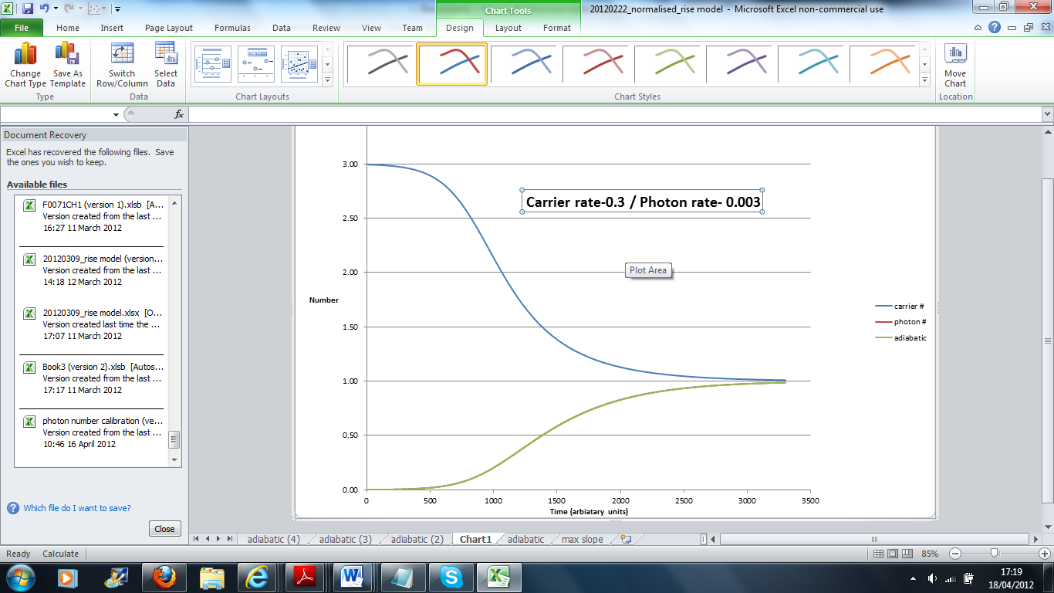

Figure 6.1

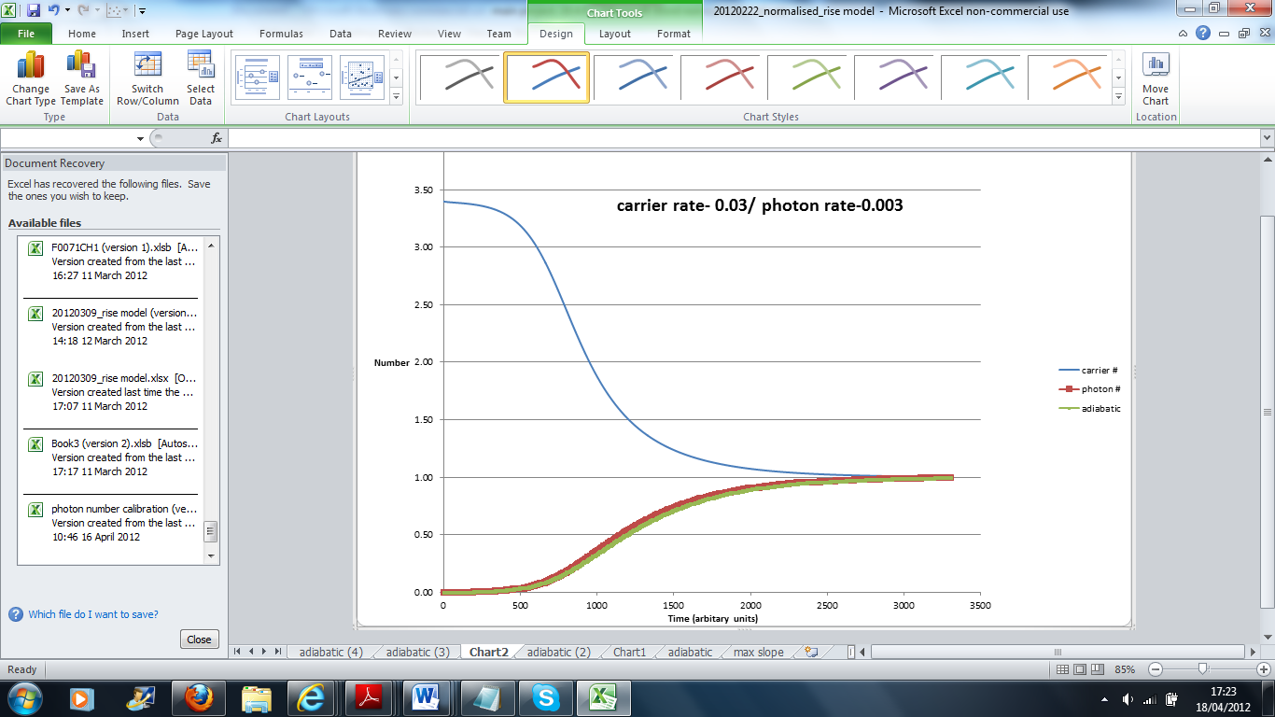

Figure 6.2

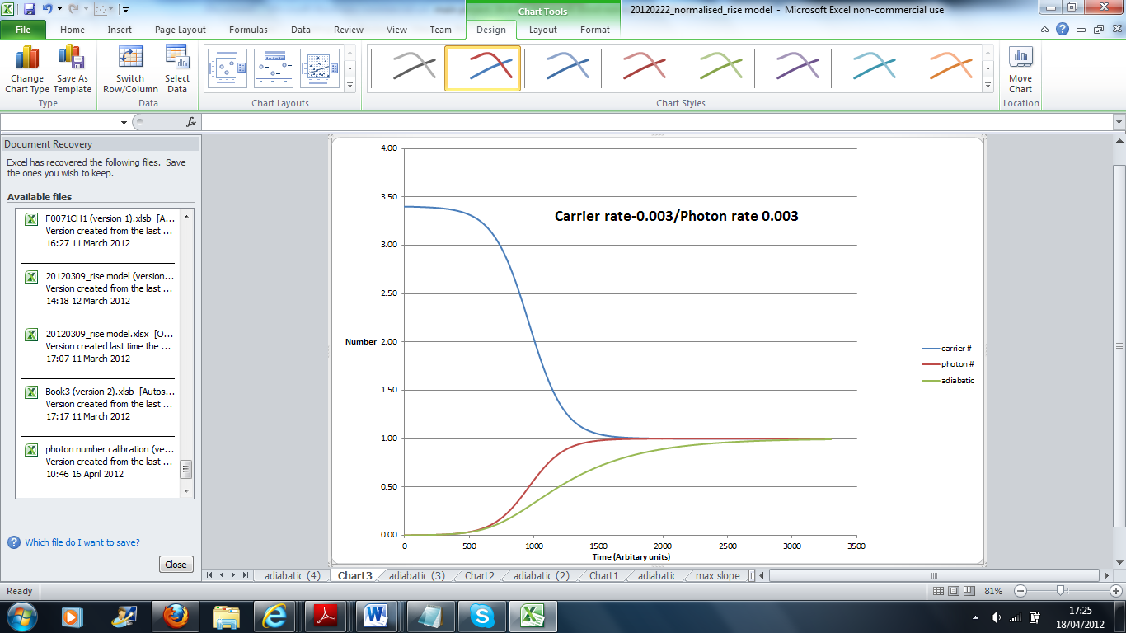

Figure 6.3

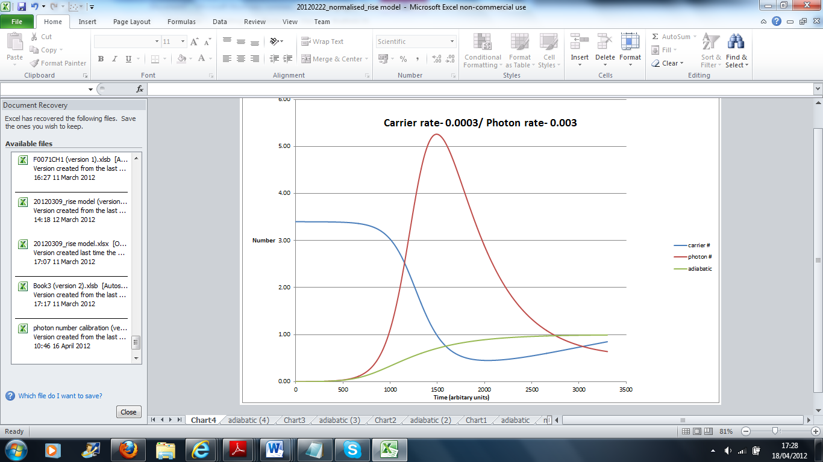

Figure 6.4

It’s seen that when the carrier rate is one hundred times less than the photon rate the curve, assuming the adiabatic limit is identical to the four level laser curve. As the carrier rate is reduced deviations away from the curve assuming adiabatic limit are found, and as the carrier rate drops below the photon rate class B relaxation oscillations can be seen.

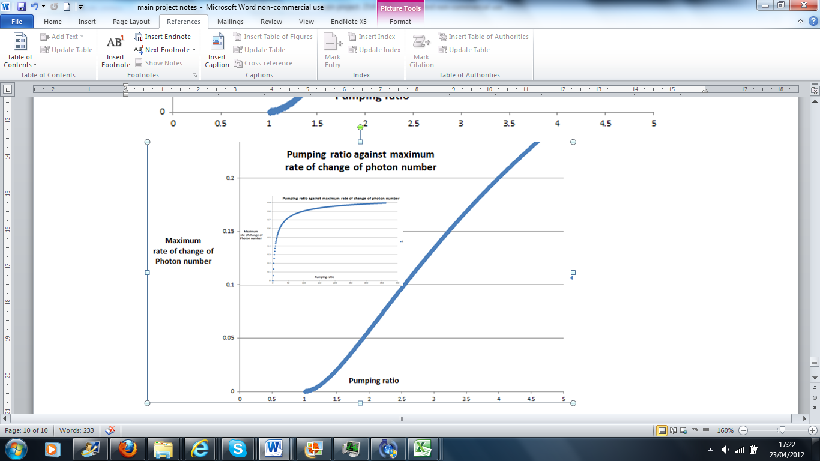

Figure 6.4

The last shows the maximum rate of change of photon number as a function of the pumping ratio. At low pumping ratio’s the fit looks to be linear however there is a slow rise and the rise does tail of exponentially at higher pump powers. **7. Results and Discussion**

## *Pump calibration and Input Output curves*

Figure 7.1

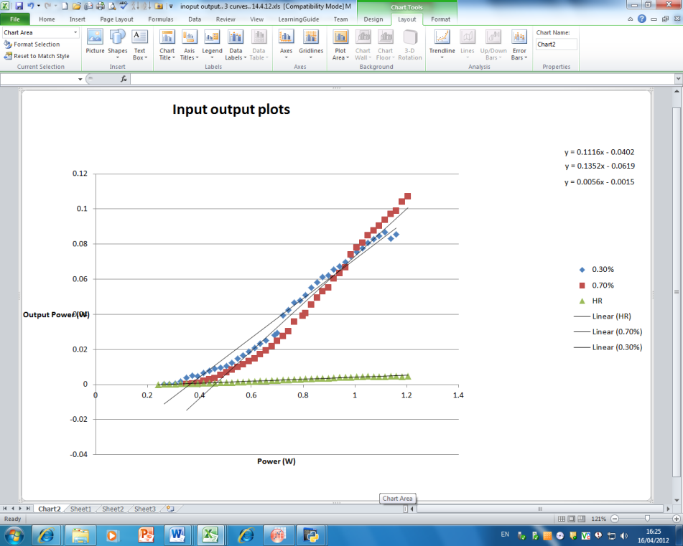

Figure 7.2

The three output couplers have a slope efficiency of 11% (0.3% OC), 14% (0.7%) and 0.6% (HR OC). Thus it can be concluded that the most efficient output coupling for this laser cavity to give maximum power lies between a 0.3% and a 0.7% output coupler. This follows the theory for laser output power. The gentle curve to at the start is characteristic to an input output curve, and shows that the stimulated emission does not immediately take off once pumping has increased above threshold. This implied the population inversion/ carrier rate does not increase in a linear relationship at powers near threshold. Further imperfections deviating from the linear fit are likely to be caused by the laser moving into another transverse mode.

$P=AIT_{2}$ (37)

*I=Intensity*

$A$*=Area of laser mode*

$T_{2}$*=Output coupler transmission*

It is seen from equation (6.1) that it implied the power should increase with output coupling, however the equation can be recast.

$P=\frac{AI_{s}}{2}T_{2}(x-1)$ (38)

$I_{s}$*=saturation intensity= $\frac{hν}{στ}$*

*x=Pumping ratio*

Equation (6.2) shows that output power has dependence on the pumping ratio that is directly related to the threshold pumping power. Physically speaking this follows that the smaller the output coupling then the overall cavity losses are greater, and thus a higher pumping power is needed to overcome the losses in the cavity to induce stimulated emission. So whilst in theory the HR output coupler should have the lowest threshold for lassing, the minimal transmission will cause a low output power and slope efficiency.

## *Photon Rise Times*

Figure (7.3) shows a piece of rise time data. The photon number begins to rise as the optical chopper is opened, allowing photons to oscillate in the cavity thus leading to stimulated emission. As the gain chip was being pumped carriers were being excited and only de-exciting by spontaneous emission and so most of the energy is stored in the gain. Class A dynamics of the VECSEL laser exhibiting no relaxation oscillations, with a smooth curve into the steady state photon number as expected from the characteristically short carrier lifetime. Alerting the photon lifetime the data can be fitted to the model (figure). If the experimental data shows a good fit with the photon rise time then then an approximation of the carrier density can be made within the constraints of the model.

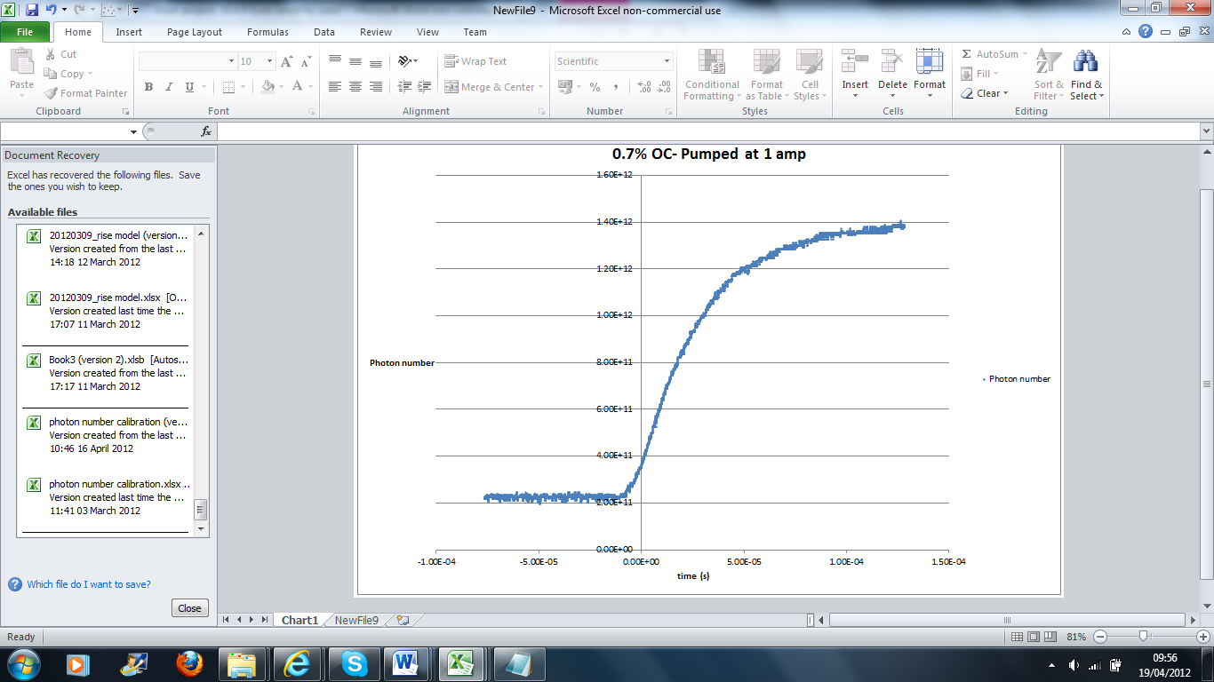

Figure 7.3– Final cavity design. Pumped at 1 amp- 0.7% output coupler

## 

Figure 7.4– Final cavity design. Pumped at 1 amp- 0.7%

output coupler- with the model

When fitting the data to the model it was found that the curve could be well fitted at the beginning of the rise time or at the end, however a compromise had to be made when fitting to the entire curve. This is a likely result of the 4 level gain approximations in a real semiconductor gain material.

## *Photon Rise time as a function of output coupler*

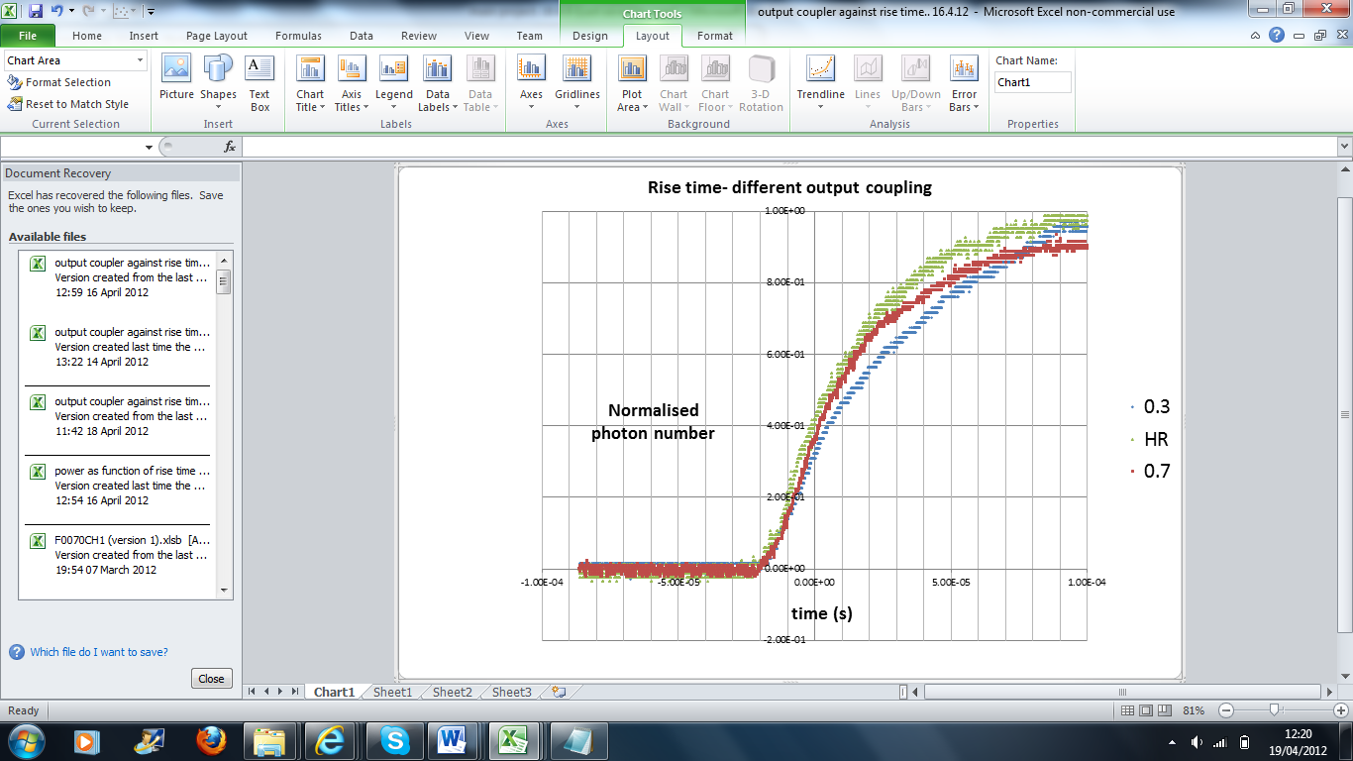

Figure 7.5 – Final cavity design Different output coupling

The graphs of the rise time against output coupler were plotted against the model and a best fit was found. From this the cavity lifetime was recorded for each output coupler

|  |  |  |  |
| --- | --- | --- | --- |
| Output coupler | Cavity model rate | Cavity model Rate $s^{-1}$ | Cavity loss |
| 0.7 | 0.0021 | |  | | --- | | 105000 | | |  | | --- | | 0.00015 | |
| 0.3 | 0.0012 | 60000 | 0.00009 |
| HR | 0.001 | 50000 | 0.00007 |

These times would be expected as the greater transmission in the output coupler the larger the cavity loss giving a slower photon decay rate.

Analysis of the decay rates in the cavity, whilst they show the correct trend, all are too low to be possible in a working cavity. Using the cavity lifetime as 1.47ns the following formula can be applied to give the values in table 7.1:

$\frac{1}{τ_{photon}}=\frac{c}{2l}×loss$ (38)

It is seen that the cavity loss is far less than the output coupler transmission percentage. This is likely to be due to an electronic property of the preamplifier being used that as slowed the rise time down, whilst maintaining the same trend. Normally for a VECSEL laser loss would be expected to be approximately 1%.

## *Photon rise time as a function of power*

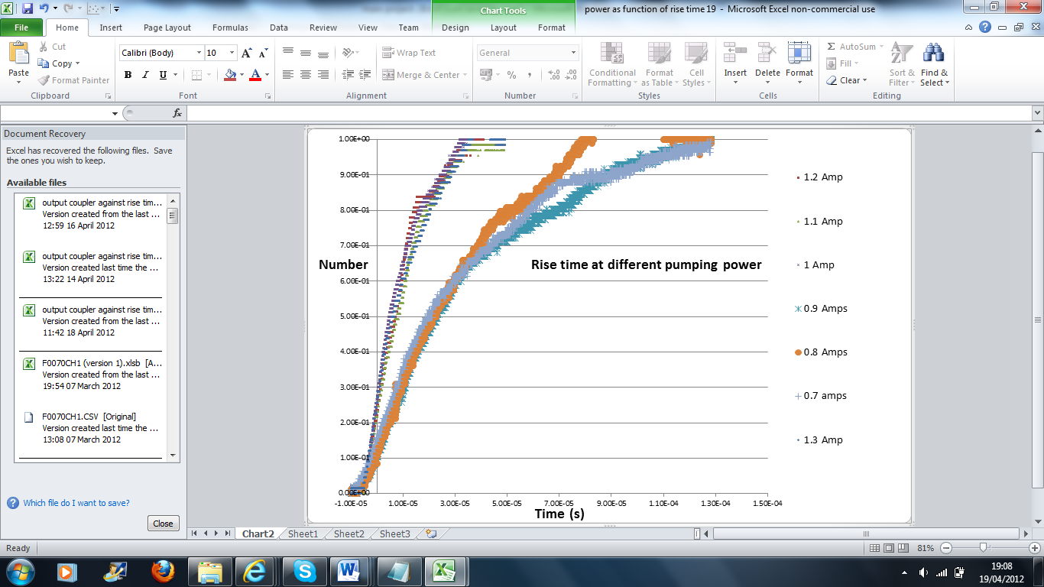The 0.3% output coupler was used to investigate the change in the rise time with a change in the pumping power.

Figure 7.6

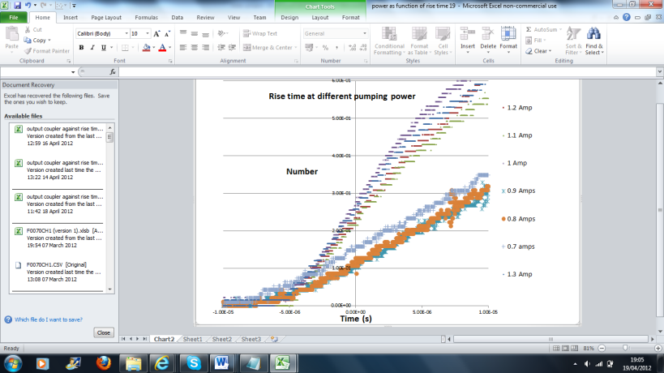

Figure 7.7

The data shows a divided trend between high and low pumping powers. It would be expected that there should be a trend that shows an increase in pumping ratio would lead to a decrease in rise time. The model predicted this trend , figure 6.7.The data does show that the group of higher powers do give a shorter rise time than the group at lower power however there is not a continuous trend of rise time to power. Figure 6.7 predicts how the photon number changes with the pumping ratio however the photon number will not follow a linear relationship with the pumping ratio as the input output curve shows, figure 7.2, a gradual rise in the output intensity at low pumping ratios. It can also be seen that the 0.3% and 0.7% output coupler are showing rollover and possible saturation of gain. . When this is considered the lower pumping ratios will not be experiencing a significant photon rise and similarly the higher powers will not be experiencing a significant photon rise, and thus this could explain the bunching in rise times of higher and lower pumping ratios.

*Analysis from Kuznestov model [1],[2].*

The equations produced by kuznestov highlight s another approximation in our mathematical analysis of the data. Equation 14 shows that carrier lifetime is infact a function of the carrier number N.

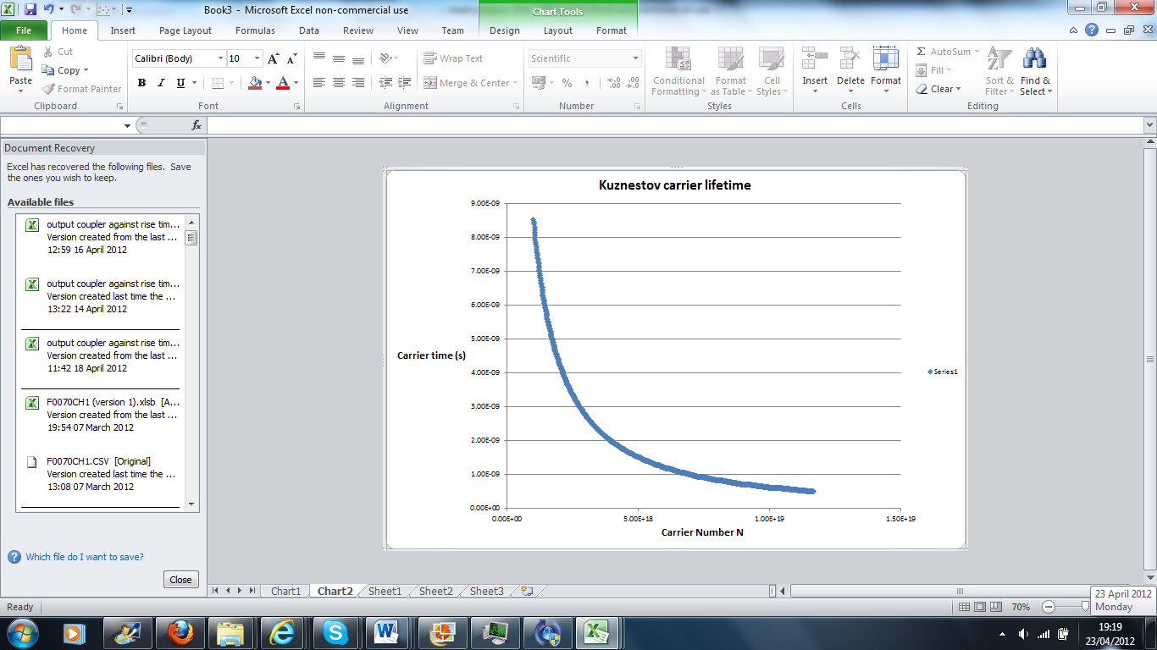

Previously the model assumed a relationship with the proportionality of equation 15 but with a fixed carrier lifetime and this a linear relationship. This would certainly contribute to errors and deviations from the data in the model. .

Applying equation 16 to the parameters of the semiconductor chip and cavity used in the experiment a theoretical calculation of carrier density at threshold is calculated. Using the following parameters from Kuznestov the carrier density at threshold was $$1.7×{10}^{18}$$

|  |  |  |  |
| --- | --- | --- | --- |
| Symbol |  | value | Unit |
|  | Material gain coefficient | 2000 |  |
|  | Transparency carrier density | $$1.7×{10}^{18}$$ |  |
|  | Longitudinal confinement factor | 2 |  |
|  | Quantum well thickness | 6 |  |
|  | On wafer mirror reflectivity | 0.99 |  |
|  | Round trip transmission loss | 0.99 |  |
|  | Laser wavelength | 1015 |  |
|  | Pump wavelength | 830 |  |
|  | Pump spot diameter |  |  |
|  | Pump absorption efficiency |  |  |
|  | Monomolecular recombination coefficient | $$1.0×{10}^{7}$$ |  |
|  | Bimolecular recombination coefficient | $$1.0×{10}^{-10}$$ |  |
|  | Auger recombination coefficient | $$6×{10}^{-30}$$ |  |
|  |  |  |  |

[SOME MORE KUZNESTOV ANALYSIS AND COMPARISONS

# 8. Conclusions and Future work

A VECSEL cavity was produced and optimised such that rise time data was obtained. Slope Efficiency’s of the laser were taken with different output couplers with a maximum effiency of 14% for a 0.7% output coupler. The rise time was fitted to a model based on a four level laser transition and the laser rise time was found to be to slow to be a real value possibly due to the electronics of the pre amplifier.

The data showed a clear trend of decreasing rise time with decreasing output coupler transmission. Further to this data showed an increase in the pump power would shorten the laser rise time. The nonlinear relationship between the pumping ratio and carrier number caused the rise times to bunch up at higher power and low power, where pumping ratio has less of an effect on the carrier number, and thus the laser gain.

The logical step for future work with the laser would be to be to add components into the cavity that would cause nonlinear loss. Further to good alignment and a better quality frequency doubling crystal then intracavity doubling can occur to output green light. The rise time data can then be collected for the cavity and compared against a cavity with no non linear loss. The cavity showed to exhibit a large number a spatial modes. An investigation into quantifying the slope efficiency in the different spatial modes could be performed and an optimal mode for maximum power could be found.

The cavity exhibited a variety of spatial modes. Two of these modes were fitted to a the theoretical intensities for the given modes. The laser also showed to exhibit a large number of higher order modes. These were a result of poor cavity alignment and spot mismatching on the gain chip.

[more conclusion coming]

# 9. References

[1] Kuznetsov. M, 1997,” High-Power (>0.5-W CW) Diode-Pumped Vertical-External-cavity Surface-Emitting Semiconductor Lasers with Circular ${TEM}_{00}$ Beams”, *IEEE PHOTONICS TECHNOLOGY LETTERS*, VOL 9, NO 8

[2] Kuznetsov. M, “VECSEL Semiconductor Lasers: A Path to High Power, Quality Beam and UV to IR Wavelength by Design”

[3]Kenichi. Iga, 2000, “Surface-Emitting laser- Its Birth and generation of New Optoelectronics Field”, *IEEE PHOTONICS TECHNOLOGY LETTERS*, VOL 6, NO 6

[4] Keller. U, Tropper. A, 2006, “Passivly modelocked surface emitting semiconductor lasers”, *Physics Reports* 429, 67-120

[5] Tropper. A C, Foreman. F D, Garnache A, Wilcox. K G, Hoogland. S H, 2004, “Vertical-external-cavity semiconductor lasers”, *Journal of Physics D: Applied Physics, Phys 73, R75-R85*

[6] Coherent, “Short Upper State Lifetime Eliminates “Green Problem,” Setting the Industry Standard for Lowest Overall Noise” , [www.Coherent.com](http://www.Coherent.com)

[7]Coherent, “Single Longitudial Mode Operation key to superior coherence and Extreemly Low Noise”, [www.Coherent.com](http://www.Coherent.com)

[8] Lin. J, Pask. H M, Lee. A J, Spence D J, “Study of Amplitude Noise in a Continuous-Wave Intracavity Frequency-Doubled Raman laser”, *IEEE PHOTONICS TECHNOLOGY LETTERS*, VOL 47, NO 3

[9] Coherent, “Optically Pumped Semiconductor Lasers”, [www.Coherent.com](http://www.Coherent.com)

[10] Numai. T, 2004, Springer, “Fundamentals of Semiconductor lasers”, New York, 218-220

[11] Barnes . M E, Mihoubi. Z, Wilcox. K G, Quaterman. A H, Farrer. I, Ritchie. D A, Garnache. A, Hoogland. S, Apostolopoulos. V, Tropper. A C, 2010, “Gain bandwidth characterization of surface emitting quantum well laser gain structures for femtosecond operation”, *Optics Express, Vol 18, No 20*

[12] Demtroder. W, 2008, Springer, “Laser Spectroscopy: Experimental techniques”, Germany, 13-21

[13 ] Silfvast, W.T.,1996, *Laser Fundermentals,* Cambridge University Press, (page)

[14]

Spencer, E.G, Zitter, R.N, 1966, “Infrared and Visible Laser Modulation using Faraday Rotation in YIG” *Journal of Applied Physics*, Volume 37, Number 3

[15]

Boucart. J, Fortin. C, Goldstein. L, Jacquet. J, Poussou. C, Rocher. A, Starck. C, 1998, “GaAlAs/GaAs metamorphic Bragg mirror for long wavelength VCSEL’s”, IEE, Electronic Letters online No:19980117

[16 ]Hawkes, J.F.B. and Wilson, J., 1987, *Lasers*

# Apendix 1

$$d∅=\left(∅\left[g_{o}N_{}- \frac{1}{τ_{c}}\right]\right)dt$$

$dN_{2}=\left(Γ-g_{o}∅N_{}- \frac{N_{}}{τ}\right)dt$

The steady state solutions for these equations are solutions to $\frac{d∅}{dt}=0$ and $\frac{dN}{dt}=0$

$$\frac{d∅}{dt}=0, so ∅= ∅_{0}≠0$$

$$N=N_{0}=\frac{1}{g_{o}τ_{c}}$$

$\frac{dN}{dt}$ =0

$$Γ=g_{o}N_{0}∅_{0}-\frac{N_{0}}{τ_{c}}$$

$$∅_{0}=\frac{Γ+\frac{N_{0}}{τ}}{g_{o}N_{0}}$$

$$∅_{0}=\frac{Γτ+\frac{1}{g_{o}τ_{c}}}{\frac{g_{o}}{g_{o}τ_{c}}}$$

Introducing $x=\frac{∅_{}}{∅_{0}}$ and y= $\frac{N}{N_{0}}$

$$\frac{dx}{dt}=g_{0}Nx-\frac{x}{τ_{c}}$$

$$\frac{dx}{dt}=g_{0}N_{0}xy-\frac{x}{τ_{c}}$$

$$τ_{c}\frac{dx}{dt}=xy-x$$

$$\frac{dy}{dt}=\frac{Γ}{N_{0}}-g_{0}y∅_{0}x-\frac{y}{τ}$$

$$τ\frac{dy}{dt}= τ Γg_{0}τ_{c}-g_{0}\left[\frac{Γτ+\frac{1}{g_{0}τ_{c}}}{\frac{1}{τ_{c}}}\right]xy-y$$

$$τ\frac{dy}{dt}= τ Γg_{0}τ_{c}-\left[τ Γg_{0}τ_{c}+1\right]xy-y$$

Letting R= $g_{0} Γτ_{c} τ$

$$τ\frac{dy}{dt}= R-\left[R+1\right]xy-y$$

In the adbiatic limit $τ≪τ_{c}$ y follows x adibiaticlly and $\frac{dy}{dt}=0$.

In the adibiatic limit

$$R=y+\left[R+1\right]xy$$

$$R=y\left[1+\left(R+1\right)x\right]$$

$$y=\frac{R}{1+\left(R+1\right)x}$$

$$τ_{c}\frac{dx}{dt}=\frac{xR}{1+\left(R+1\right)x}-x$$

Taking the second differential of photon ratio

$\frac{d^{2}x}{dt^{2}}τ_{c}=0$ = $\frac{d}{dt}\left[\frac{xR}{1+\left(R+1\right)x}\right]$

$$x=\frac{\sqrt{R}-1}{R+1}$$ $$\frac{d^{2}x}{dt^{2}}(max)=\frac{{\left[\sqrt{R}-1\right]}^{2}}{R+1}$$